David J. Kingston Community Service Scholarship

The family of David J. Kingston will be awarding a $500.00 scholarship in memory of David to a student who has completed (1) year of college (part-time or full-time) in an ag-related or technical school curriculum.

Applicants must be:

- Active on an Upstate Niagara Cooperative member farm (son or daughter of a member, or employed by a member).
- Enrolled in an ag-related field.
- Entering at least their second (2nd) year as a part-time or full-time student.

All applications must include:

- Completed application with essay. (Blank forms available from the membership department of Upstate Niagara at 1-800-724-MILK)
- College transcripts.
- Letter of recommendation from a community member. Letter must include the name of the applicant, name of person writing the letter, comments on the applicant’s character and abilities as well as their involvement in the community. A parent or close relative cannot write this letter.
- Letter of recommendation from Member Farm. A parent can submit this letter of recommendation.

The deadline for returning applications to Upstate Niagara is July 1, 2024 (revised deadline). The scholarship committee will review the applications. The award will be presented by August 1st.

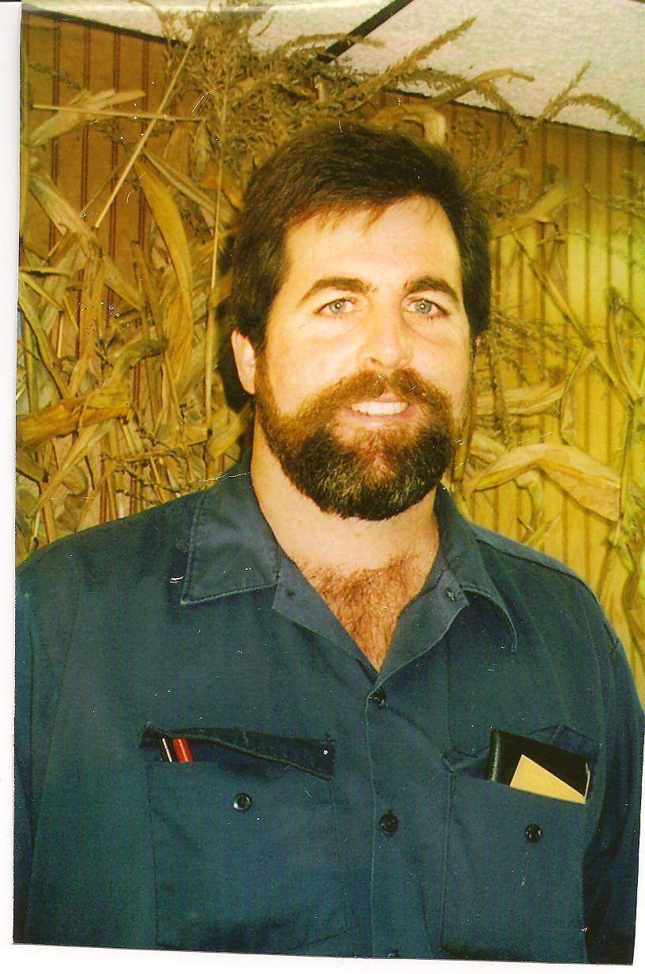 David J. Kingston Community Service Scholarship Application

NAME _____________________________________________________________________________________________________

PERMANENT ADDRESS____________________________________________________________________________________

____________________________________________________________________________________________________________
CITY STATE ZIP

PHONE NO. (home)____________________________________ (cell)_____________________________________________

DATE OF BIRTH___________________________ SOCIAL SECURITY NO.________________________________________

APPLICANT’S RELATIONSHIP TO UPSTATE NIAGARA FARM MEMBER:
___________________________________________ (include the member’s letter of recommendation)

MEMBER’S NAME, MEMBER #, PHONE # & ADDRESS:____________________________________________________

____________________________________________________________________________________________________________

____________________________________________________________________________________________________________

COLLEGE ATTENDING:_____________________________________________________________________________________

ADDRESS:__________________________________________________________________________________________________

DECLARED MAJOR:________________________________________________________________________________________

CUMULATIVE GRADE POINT AVERAGE:____________ TRANSCRIPTS INCLUDED? _________________________
(If no, please forward as soon as possible)

Include a short essay relating to your major, your future employment goals and the importance of community involvement. Include school and farm activities. Please limit your essay to 300 words.

Applicant’s Signature_________________________________________________________________

***RETURN NO LATER THAN JULY 1ST TO: UPSTATE NIAGARA COOPERATIVE, INC.
SCHOLARSHIP COMMITTEE
700 ELLICOTT STREET, SUITE 2
BATAVIA, NY 14020
FAX: (585) 815-6821

Please refer any questions to Michelle Howard at
mhoward@uncdairy.com or 1-800-724-6455 ext. 6430.

